GMT Slit Diffraction Calculator

B. McLeod

Smithsonian Astrophysical Observatory

Version: 1.0

Date: November 8, 2015

# INTRODUCTION

This documents the slit diffraction calculation program GMT\_SlitDiffract.py. This program computes the effective pupil area for several components of emission, including star light coming through the telescope, thermal emission from M1, thermal emission from M2, and background light from the sky.

This script deliberately decouples the geometry specific parameters from parameters that specify sky background levels and emissivities of the surfaces. This script deals only with the geometry. In a separate spreadsheet the results must then be multiplied by the appropriate factors detailed in section 2 in order to compute S/N ratios.

The script outputs a tab-delimited table listing the effective areas. The next section details how those effective areas can be converted into fluxes for a S/N calculation.

git clone [https://github.com/bamcleod/Emissivity.git](https://github.com/bamcleod/Emissivity.git" \t "_blank)

This will create a directory "Emissivity" containing among other things, GMT\_SlitDiffract.py , and a couple of necessary utilitities.

To run it you'll need to install a scientific python on your computer -- the preinstalled one on MaxOS doesn't cut it.  I'm using anaconda.

[https://store.continuum.io/cshop/anaconda/](https://store.continuum.io/cshop/anaconda/" \t "_blank)

# Effective Area Components

## Light from sky that goes through telescope

Column name: **thrutel**

This column is used to compute two different terms:

1 – To get the flux from the target reaching the detector, the effective area is multiplied by:

Object spectrum (photons sec^-1 m^-2 micron^-1)

M1 reflectivity

M2 reflectivity

Slit losses

2 – To get the sky background contribution, the effective area is multiplied by:

Sky spectrum (photons sec^-1 m^-2 micron^-1 asec^-2)

M1 reflectivity

M2 reflectivity

Slit width (asec)

Aperture length (asec) [this is the width of the aperture used when extracting the spectrum]

## Thermal emission from M1 optic, reflected in M2

Column name: **m1emiss**

To get the flux from the M1 thermal emission multiply by:

Black Body spectrum (photons sec^-1 m^-2 micron^-1 asec^-2)

M1 emissivity

M2 reflectivity

Slit width (asec)

Aperture length (asec)

The temperature of the Black Body should be the temperature of the telescope.

## Thermal emission from M1 surrounding structure

Column name: **m1struc**

This term is for thermal emission from the areas surrounding M1, then reflecting off M2 and going into the instrument. It is assumed that all the structure surrounding M1 has emissivity=1.

Multiply by:

BB spectrum

M2 reflectivity

Slit width

Aperture length

## Thermal emission from M2 optic

Column name: **m2emiss**

This term is for thermal emission from the reflective surface of M2, which passes directly into the instrument.

Multiply by:

BB spectrum

M2 emissivity

Slit width

Aperture length

## Emission from M2 surrounding structure

Column name: **m2struc**

Multiply by:

BB spectrum

Slit width

Aperture length

## Other

All of the above terms must additionally be multiplied by

Instrument throughput (other than lyot stop)

Atmospheric transmission

One term that is missing is the contribution from light emitted by M2 and its surroundings, reflected in M1, then again in M2, and into the instrument. This light will be blocked by a central obscuration in the Lyot stop. This part of the Lyot stop is modeled, so the omission of this light source should be small.

# Input parameters to the script

The script takes the following command line arguments:

-h, --help show this help message and exit

--wave=WAVE units=meters default=2.4e-06 This is the wavelength of the calculation

--slitwid=SLITWID units=arcsec default=0.5. This is the width of the slit in arcseconds. For purposes of the slit diffraction calculation the length of the slit is assumed to be 10arcsec, which causes negligible diffraction.

--fldang=FLDANG units=arcmin default=0.0. This is the field angle in arcminutes.

--m2type=M2TYPE options: base,cyl,tallcyl,bigm2,filledcyl default=base These are the supported types of M2 geometry, and correspond to the memo XXX. Most simple geometries can be approximated using the “base” geometry with appropriate values of m2skirt and m2baff.

--m2skirt=M2SKIRT units=meters default=0.0005 This is the width of the thermally emissive region around each segment, and is illustrated in yellow in Figure 1.

--m2baff=M2BAFF units=meters default=0.0 This is the width of the thermally emissive region around each segment, and is illustrated in orange in Figure 1.

--lyotsegrad=LYOTSEGRAD

units=meters default=4.15 See Figure 2.

--lyotcenrad=LYOTCENRAD

units=meters default=1.5 See Figure 2.

--loopvar=LOOPVAR options: none,lyotsegrad,lyotcenrad,fldang,wave,

slitwid,m2skirt,m2baff

default=lyotsegrad The script can loop over one parameter of your choice, printing a table of values

--loopmin=LOOPMIN default=3.7 The starting value for the loop.

--loopmax=LOOPMAX default=4.4 The ending value for the loop.

--loopstp=LOOPSTP default=0.05 The step size.

-r ROOT default=em\_

--saveimgs default=False Save a set of fits images. The following files

are saved:

em\_slit.fits The shape of the slit.

em\_PSFslit.fits The FFT of the slit, used to convolve with the pupil

image to compute slit diffraction.

em\_drctsky.fits Pupil image of the direct sky emission seen around M2, before the slit.

em\_drctsky\_fp.fits Pupil image of the direct sky emission seen around M2, after the Lyot stop.

em\_m1emiss.fits Pupil image of thermal emission from M1, before the slit.

em\_m1struc.fits Pupil image of thermal emission from around M1, before the slit.

em\_m1struc\_fp.fits Pupil image of thermal emission from around M1, after the Lyot stop.

em\_m2emiss.fits Pupil image of thermal emission from M2, before the slit.

em\_m2emiss\_fp.fits Pupil image of thermal emission from M2, after the Lyot stop.

em\_m2struc.fits Pupil image of thermal emission from around M2, before the slit.

em\_m2struc\_fp.fits Pupil image of thermal emission from around M2, after the Lyot stop.

em\_thrutel.fits Pupil image of light passing through the telescope, before the slit.

em\_thrutel\_fp.fits Pupil image of light passing through the telescope, after the Lyot stop.



Figure 1. M2 emissive areas. m2skirt shown in yellow, m2baff shown in orange.

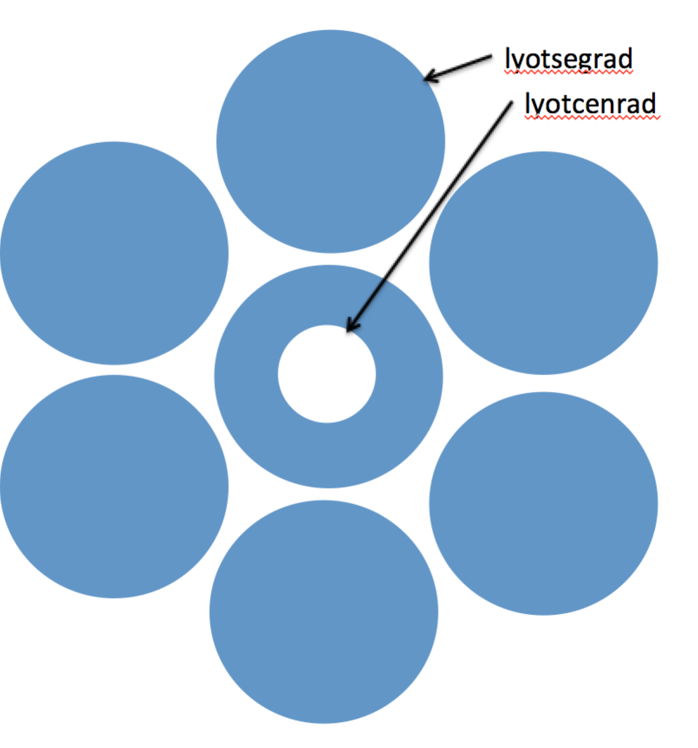

Figure . Lyot geometry

# ExampleS

## Impact of M2 structure diameter.

Here we investigate the impact of changing the diameter of the structure behind the M2 segments by using the “m2baff” parameter. We allow it to vary from 1m in radius up to 4m in radius. The output parameter that changes the most is the M2 structure. It increases rapidly and then flattens out because the M2 structure is sufficiently larger than the Lyot stop, little additional light is diffracted though the stop. At the same time, the direct view of the sky is blocked.

python GMT\_SlitDiffract.py --loopvar m2baff --loopmin 1.0 --loopmax 2.0 --loopstp 0.2 --lyotcen 2.0

thrutel: Effective area for light from sky hitting M1 and M2

m1emiss: Effective area for thermal emission from the reflective surface of M1

m2emiss: Effective area for thermal emission from the reflective surface of M2

m2struc: Effective area for thermal emission from the structure surrounding M2

m1struc: Effective area for thermal emission from the structure surrounding M1, reflected by M2

drctsky: Effective area for the direct view of the sky seen around the edges of M2

m2type: Type of M2 geometry

lyotseg: Radius of each segment of the Lyot stop in meters

lyotcen: Radius of central obscuration of the Lyot stop in meters

m2type fldang wave lyotseg lyotcen m2skirt m2baff slitwid thrutel m1emiss m2emiss m2struc m1struc drctsky

------ ------ ---- ------- ------- ------- ------ ------- ------- ------- ------- ------- ------- -------

base 0.000 2.40e-06 4.150 2.000 0.001 1.000 0.500 343.702 343.976 344.483 7.430 0.507 14.263

base 0.000 2.40e-06 4.150 2.000 0.001 1.200 0.500 343.693 343.976 344.483 9.285 0.507 12.408

base 0.000 2.40e-06 4.150 2.000 0.001 1.400 0.500 343.664 343.976 344.483 12.006 0.507 9.687

base 0.000 2.40e-06 4.150 2.000 0.001 1.600 0.500 343.549 343.976 344.483 17.335 0.507 4.358

base 0.000 2.40e-06 4.150 2.000 0.001 1.800 0.500 343.232 343.976 344.483 19.070 0.507 2.623

base 0.000 2.40e-06 4.150 2.000 0.001 2.000 0.500 342.504 343.976 344.483 19.955 0.507 1.738